**“Experiment 2.2”**

Student Name: **SUMIT KUMAR** UID: **20BCS8226**

Branch: **CSE** Section/Group: **808 A**

Semester: **5** Date of Submission: **17-10-22**

Subject Name: **Multimedia Technologies Lab**  Subject Code: **20CSP-339**

**1. Aim/Overview of the practical:**

Given a picture, make three copies of this picture. On one of these pictures, adjust the brightness and contrast, so that it gives an elegant look. On the second picture, change it to grayscale and the third is the original one using photopea.

**2. Which logistics used:**

Hardware Requirements: - Minimum 384MB RAM, 100 GB hard Disk, processor with 2.1 MHz

Software Requirements: - Photopea

**3. Steps for experiment/practical/Code:**

**Step 1:** Create new project on Photopea, and specify dimensions as required.

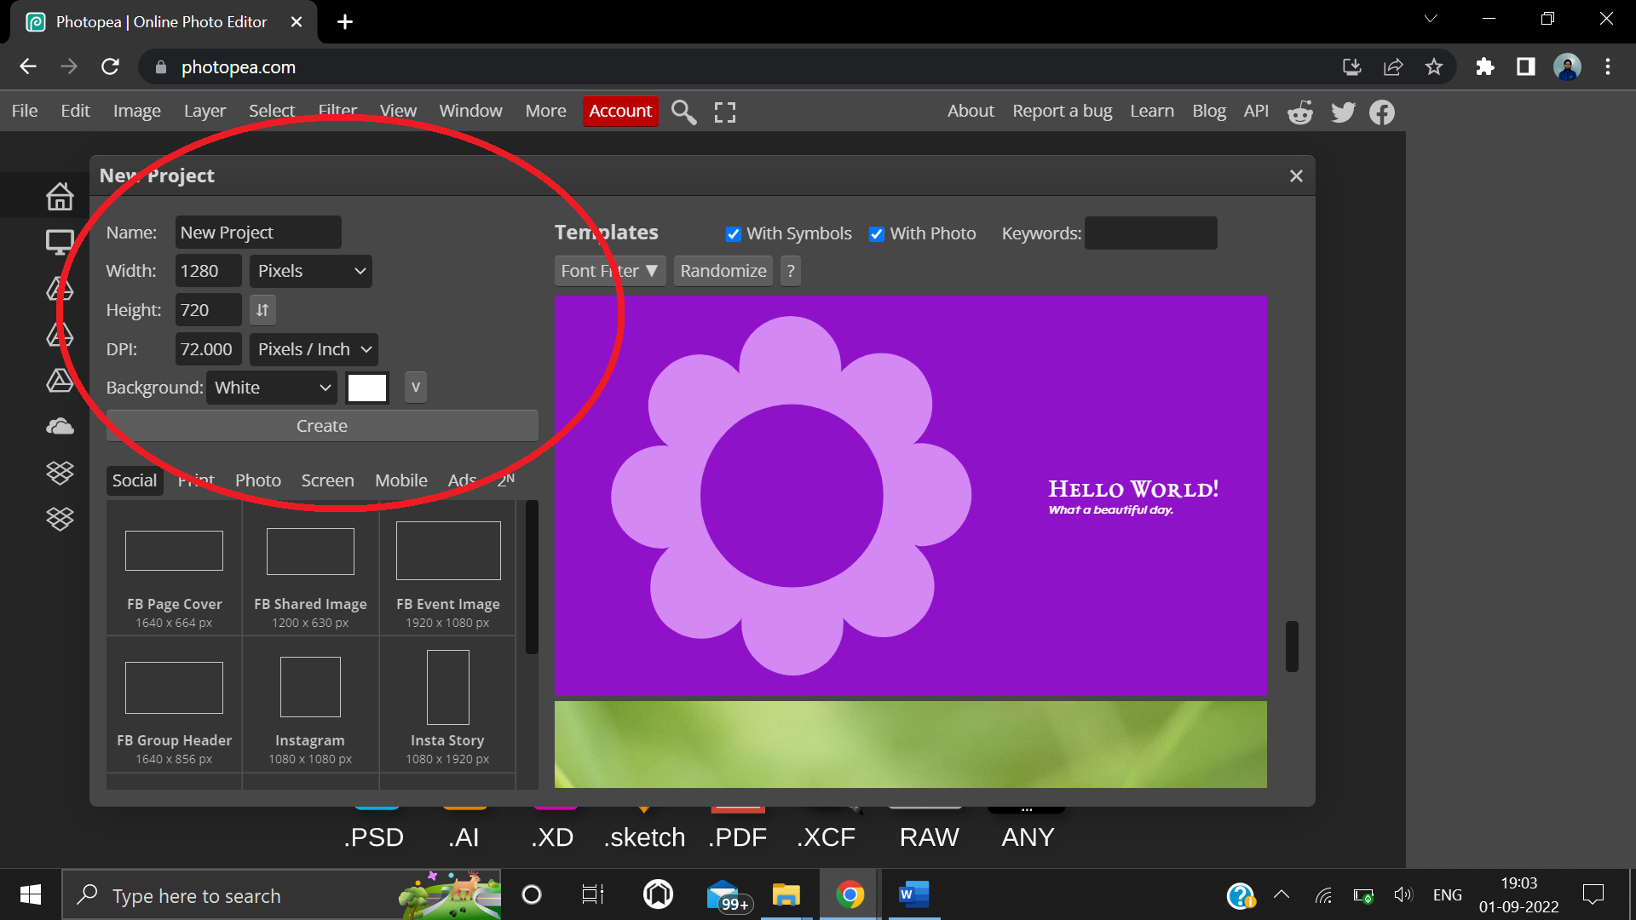

**Step 2:** Copy an image from google and paste on the screen.

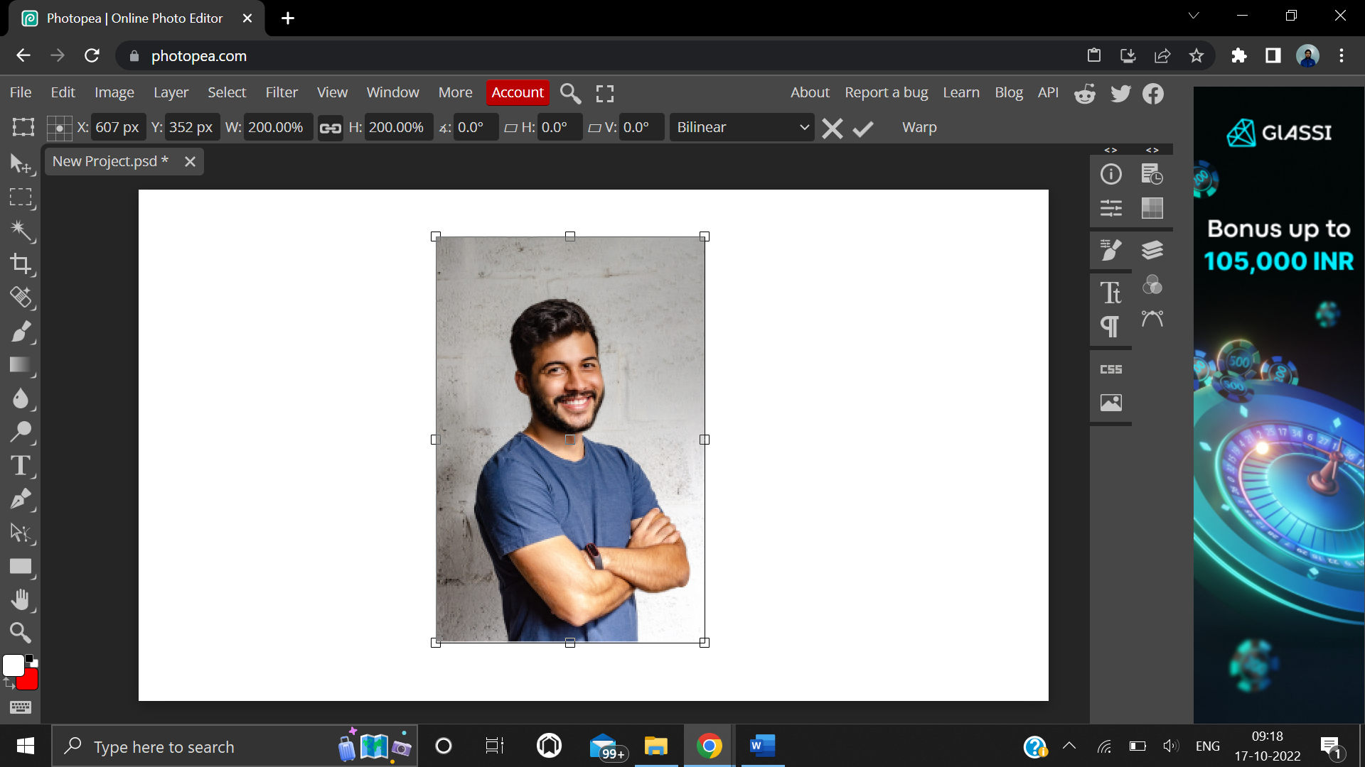

**Step 3:** Paste the image two more times, to make two copies of same image.

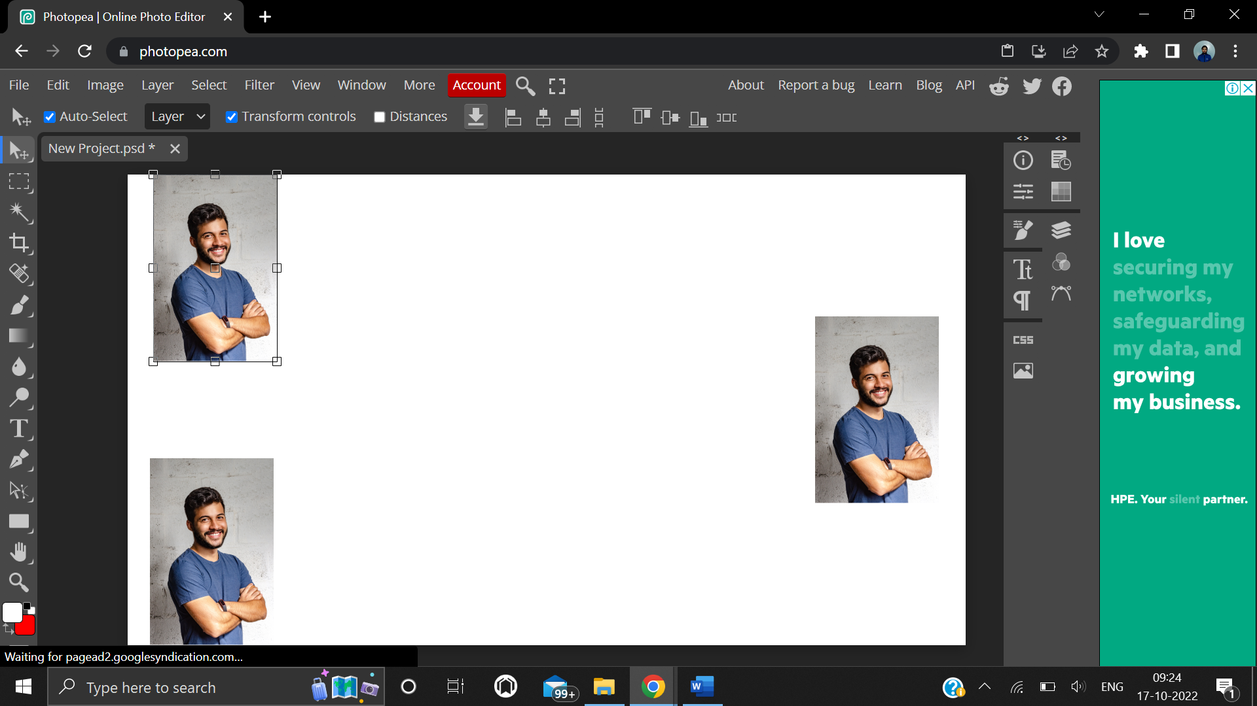

**Step 4:** Go to Layer -> New Adjustment Layer -> Brightness/Contrast.

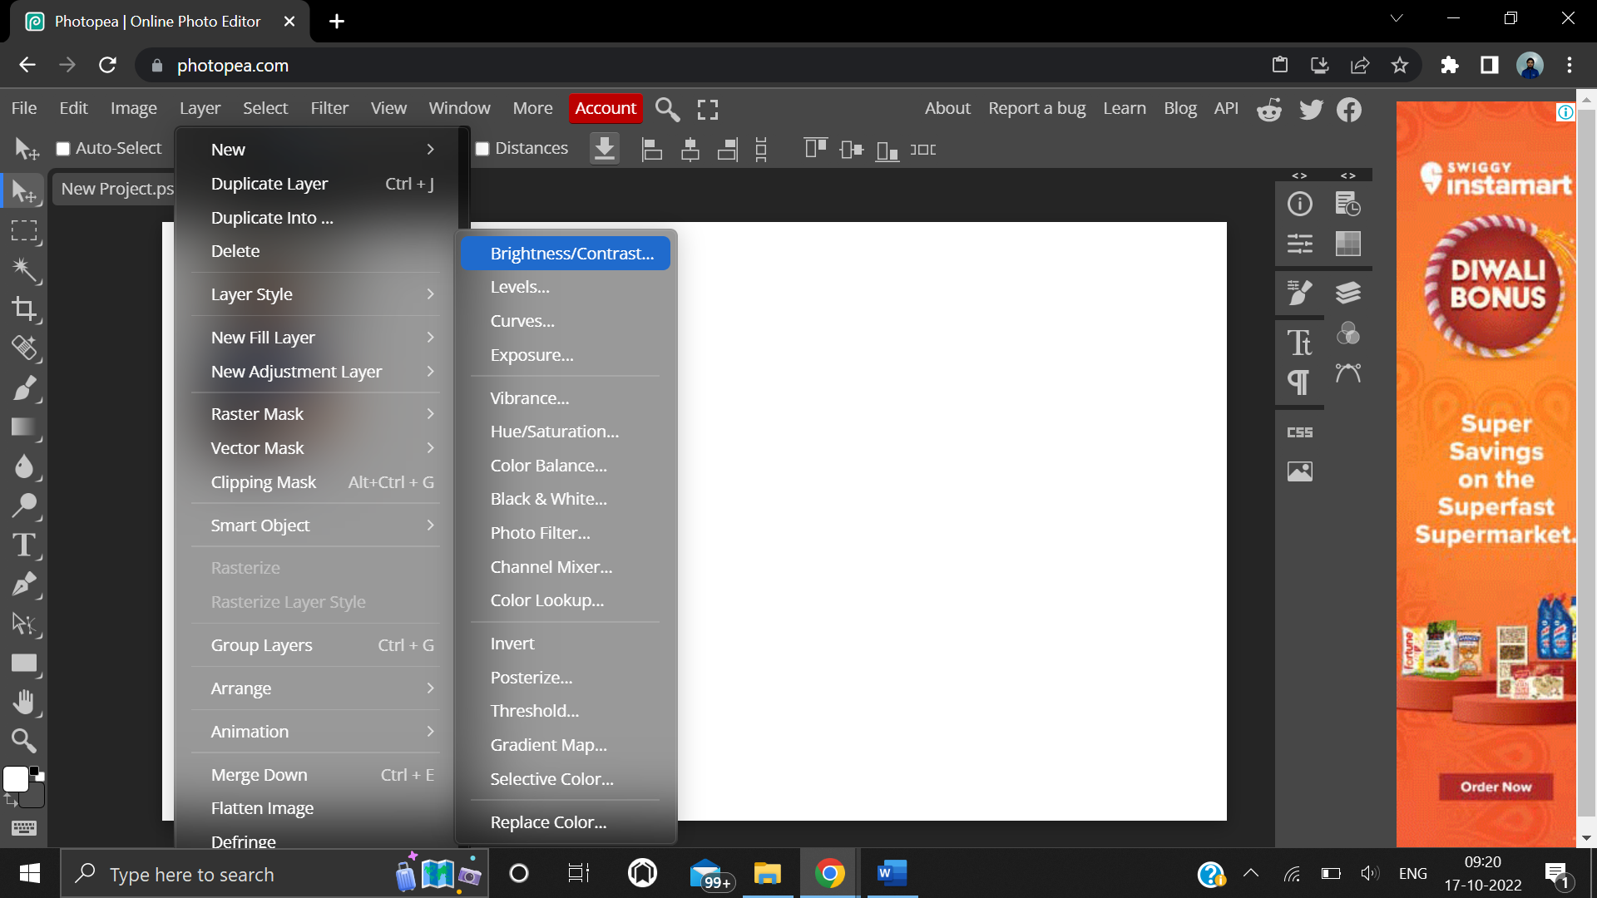

**Step 5:** Increase the brightness/contrast as per the requirement.

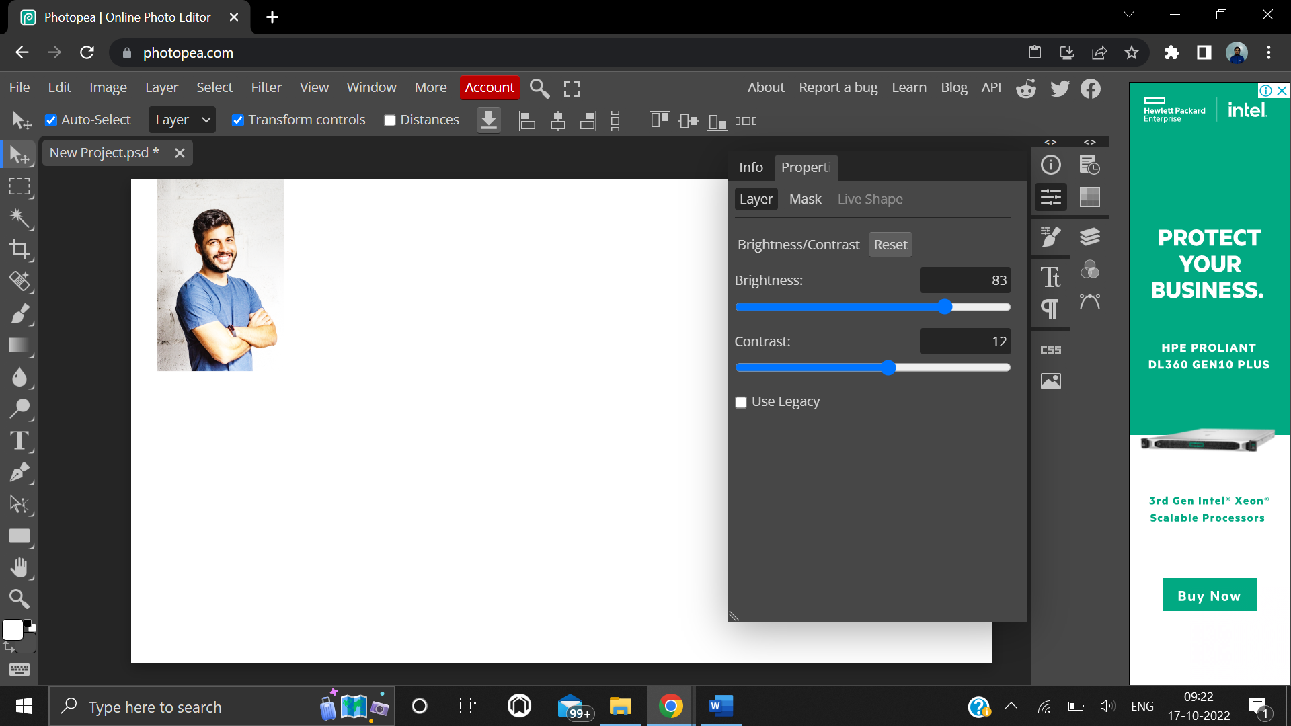

**Step 6:** Select another copy of image.

Go to Layer -> New Adjustment Layer -> Hue/Saturation.

Decrease the “Saturation” level to -100.

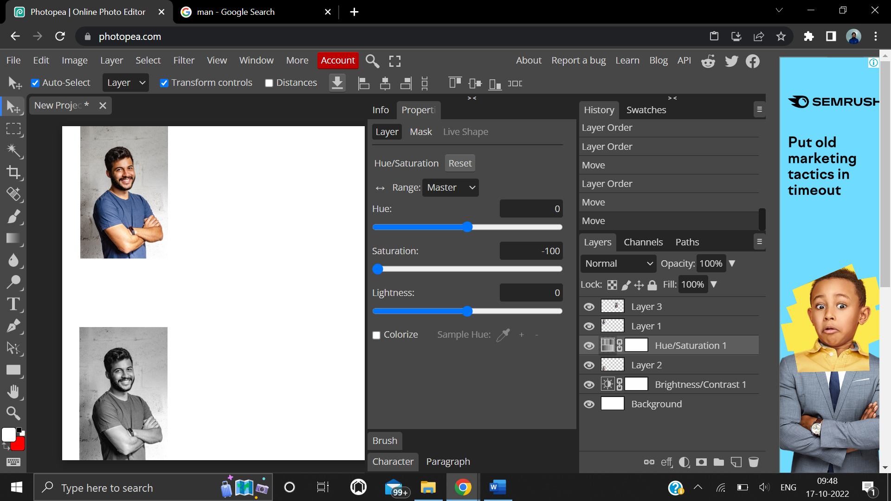

**Step 7:** Select Type Tool and write about all the 3 images.

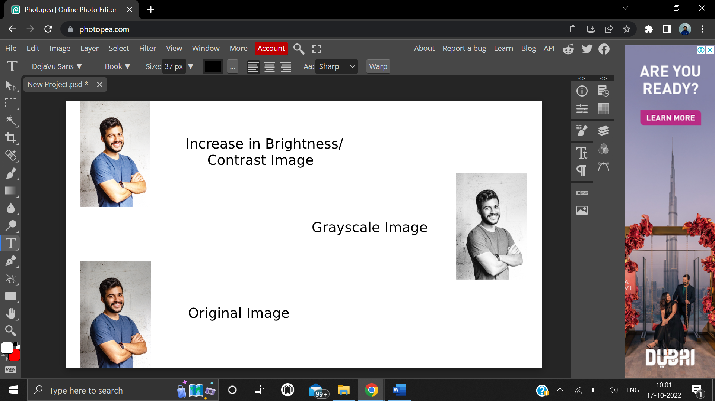

**4. Result/Output/Writing Summary:**



**Learning outcomes (What I have learnt):**

**1.** Learnt different functions / features of Layer option on Photopea.

**2.** Learnt how to increase / decrease the level of brightness and contrast.

**3.** Learnt how to make any image black and white.

**4.** Learnt how to use the Type tool.

**5.** Learnt how to increase / decrease the level of hue / saturation.

**Evaluation Grid (To be created as per the SOP and Assessment guidelines by the faculty):**

|  |  |  |  |
| --- | --- | --- | --- |
| Sr. No. | Parameters | Marks Obtained | Maximum Marks |
| 1. |  |  |  |
| 2. |  |  |  |
| 3. |  |  |  |
|  |  |  |  |